 | Air University, Islamabad

Software Design Description
(SDS DOCUMENT)

for
EZSell
Version 1.0
By
Ahmed Abbasi 220965
Dawood Haider Chaudhary 221574
Muhammad Ahmed 222550

Supervisor
Dr. Madiha Yousaf

Bachelor of Science in Artificial Intelligence (2022-2026)
Table of Contents
1. Introduction 1
2. Design Methodology and Software Process Model 1
2.1 Design Methodology 1
2.2 Software Process Model 1
3. System Overview 2
3.1 Architectural Design 2
3.2 Module Interaction Flow 3
4. Design Models. 5
4.1 Activity Diagrams 5
4.2 Class Diagram 9
4.3 System Sequence Diagram 10
4.4 State Transition Diagram 14
5. Data Design 17
5.1 Data Dictionary 18
6. Human Interface Design 19
6.1 Screen Images 19
6.2 Screen Objects and Actions 19
7. Implementation 20
7.1 Algorithm 20
7.2 External APIs/SDKs 24
7.3 User Interface 24
7.4 Deployment 28
8. Testing and Evaluation 28
8.1 Unit Testing 28
8.2 Functional Testing 30
8.3 Business Rules Testing 33
8.4 Integration Testing 34

Revision History
Name | Date | Reason for changes | Version

Application Evaluation History

Comments (by committee)  *include the ones given at scope time both in doc and presentation | Action Taken

Supervised by
Supervisor’s Name
Signature______________

Introduction
This document describes the design of EZSell, an intelligent online marketplace for buying and selling second-hand items, primarily electronics and furniture. The system aims to streamline the resale process by integrating modern technologies such as AI-driven price prediction, analytics dashboards, and user-friendly listing management. It enhances the overall marketplace experience through improved pricing accuracy, transparent user profiles, and insightful activity tracking.
So far, the project covers all essential modules required to support a complete second-hand product lifecycle. These core modules include:
- Profile Management handles user registration, authentication, verification, and account configuration for both buyers and sellers.
- Product Listing and Management enables users to post ads, upload images, edit item details, manage inventory, and control listing visibility.
- AI-Based Price Prediction generates fair and accurate price suggestions using machine-learning models based on item condition, features, and current market data.
- Analytics Dashboard provides graphical insights and statistics related to user activity, engagement trends, listing performance, and platform usage patterns.
Together, these modules create a smooth workflow from user onboarding to product posting, smart price suggestions, and useful activity insights. This document outlines the key design decisions, system architecture, components, and interfaces that support the development of EZSell.

Design Methodology and Software Process Model

Design Methodology
The system is designed using the Object-Oriented Programming (OOP) approach. Each module of the EZSell platform is modeled as a separate object that encapsulates its own attributes, functions, and responsibilities. For example:
- The User class manages authentication, verification, and user roles (Buyer, Seller, Admin).
- The Listing class handles product details, images, status updates, and listing lifecycle (create, edit, delete).
- The PricePredictor class interacts with the machine-learning model to generate fair price suggestions.
OOP was selected because it promotes modularity, code reusability, and easier long-term maintenance. Each module can be developed, tested, and updated independently without affecting others.

Software Process Model
The Agile Software Development Model is followed in this project. The system was developed in short, iterative cycles, enabling continuous testing, refinement, and feature enhancement.
Each sprint is focused on a specific module of the EZSell platform. For example, one iteration for user authentication, another for product listing management, another for AI-based price prediction, and subsequent cycles for AR visualization, recommendation features, and fraud detection mechanisms.
Agile was chosen because it supports flexibility, rapid adaptation to user feedback, and incremental integration of advanced components such as AI and AR. This approach ensures smooth progress, reduced development risks, and the ability to enhance modules without restarting the entire development lifecycle.

System Overview
EZSell is an AI-powered online marketplace built to simplify the buying and selling of second-hand electronics and furniture. The platform enables sellers to create listings with images and item details, while buyers can browse, search, filter, and contact sellers easily. Intelligent features such as AI-based price prediction, AR furniture visualization, decision-making and improve the overall user experience.
The admin dashboard provides key system insights, including active listings, user engagement, flagged posts, and category-wise trends. Admins can monitor suspicious activity, review reported listings and maintain platform safety using built-in fraud detection tools.
AI-driven recommendations help buyers discover relevant products, and the price prediction engine offers sellers fair pricing suggestions based on item attributes. The AR module allows users to preview used furniture in their own room layout using their device’s camera.
Overall, EZSell combines automation, security, and smart technology in a unified marketplace system designed to improve trust, convenience, and usability for all users.

Architectural Design
The system follows a Layered Architecture pattern with three main layers:
- Presentation Layer: User interface components including login and profile pages and product listing screens.
- Business Logic Layer: Core processing modules such as AI-based price prediction, analytics dashboard and AR visualization.
- Data Layer: Databases and storage systems that securely store users, listings, images, pricing models and activity logs.

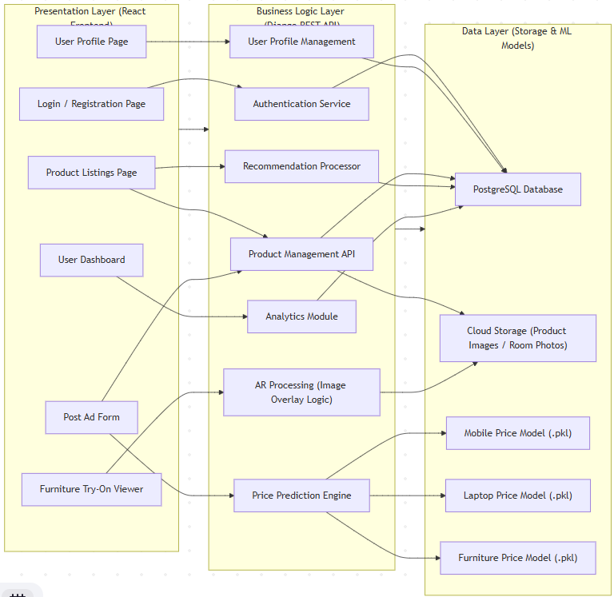

Module Interaction Flow
- The user logs in through the Profile Management Module and accesses the platform.
- Sellers create, edit, or update product listings using the Product Listings and Management Module.
- The Price Prediction Module analyzes item details and generates fair price suggestions before a listing is published.
- Buyers explore listings and use the AR Customization Module to preview furniture in their room environment.
- System activity and listing performance are processed and displayed through the Analytical Dashboard Module.
This modular workflow ensures that all components operate together smoothly. The user interface communicates only with the processing layer, while the processing layer interacts with the underlying database. This separation supports better performance, scalability, and simplified system maintenance.

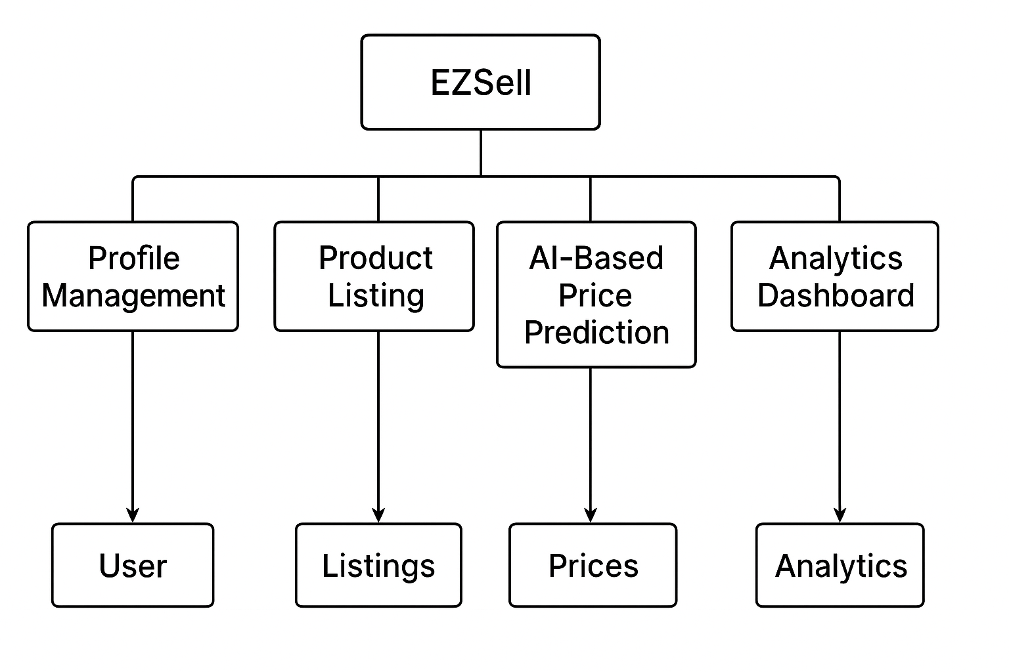

Design Models.

Design Models for Object Oriented Development Approach

Activity Diagrams

UC-1 Profile Management Module
The user enters login details, the system checks the credentials, and if valid, the user is allowed into the system. If not, an error message is shown.

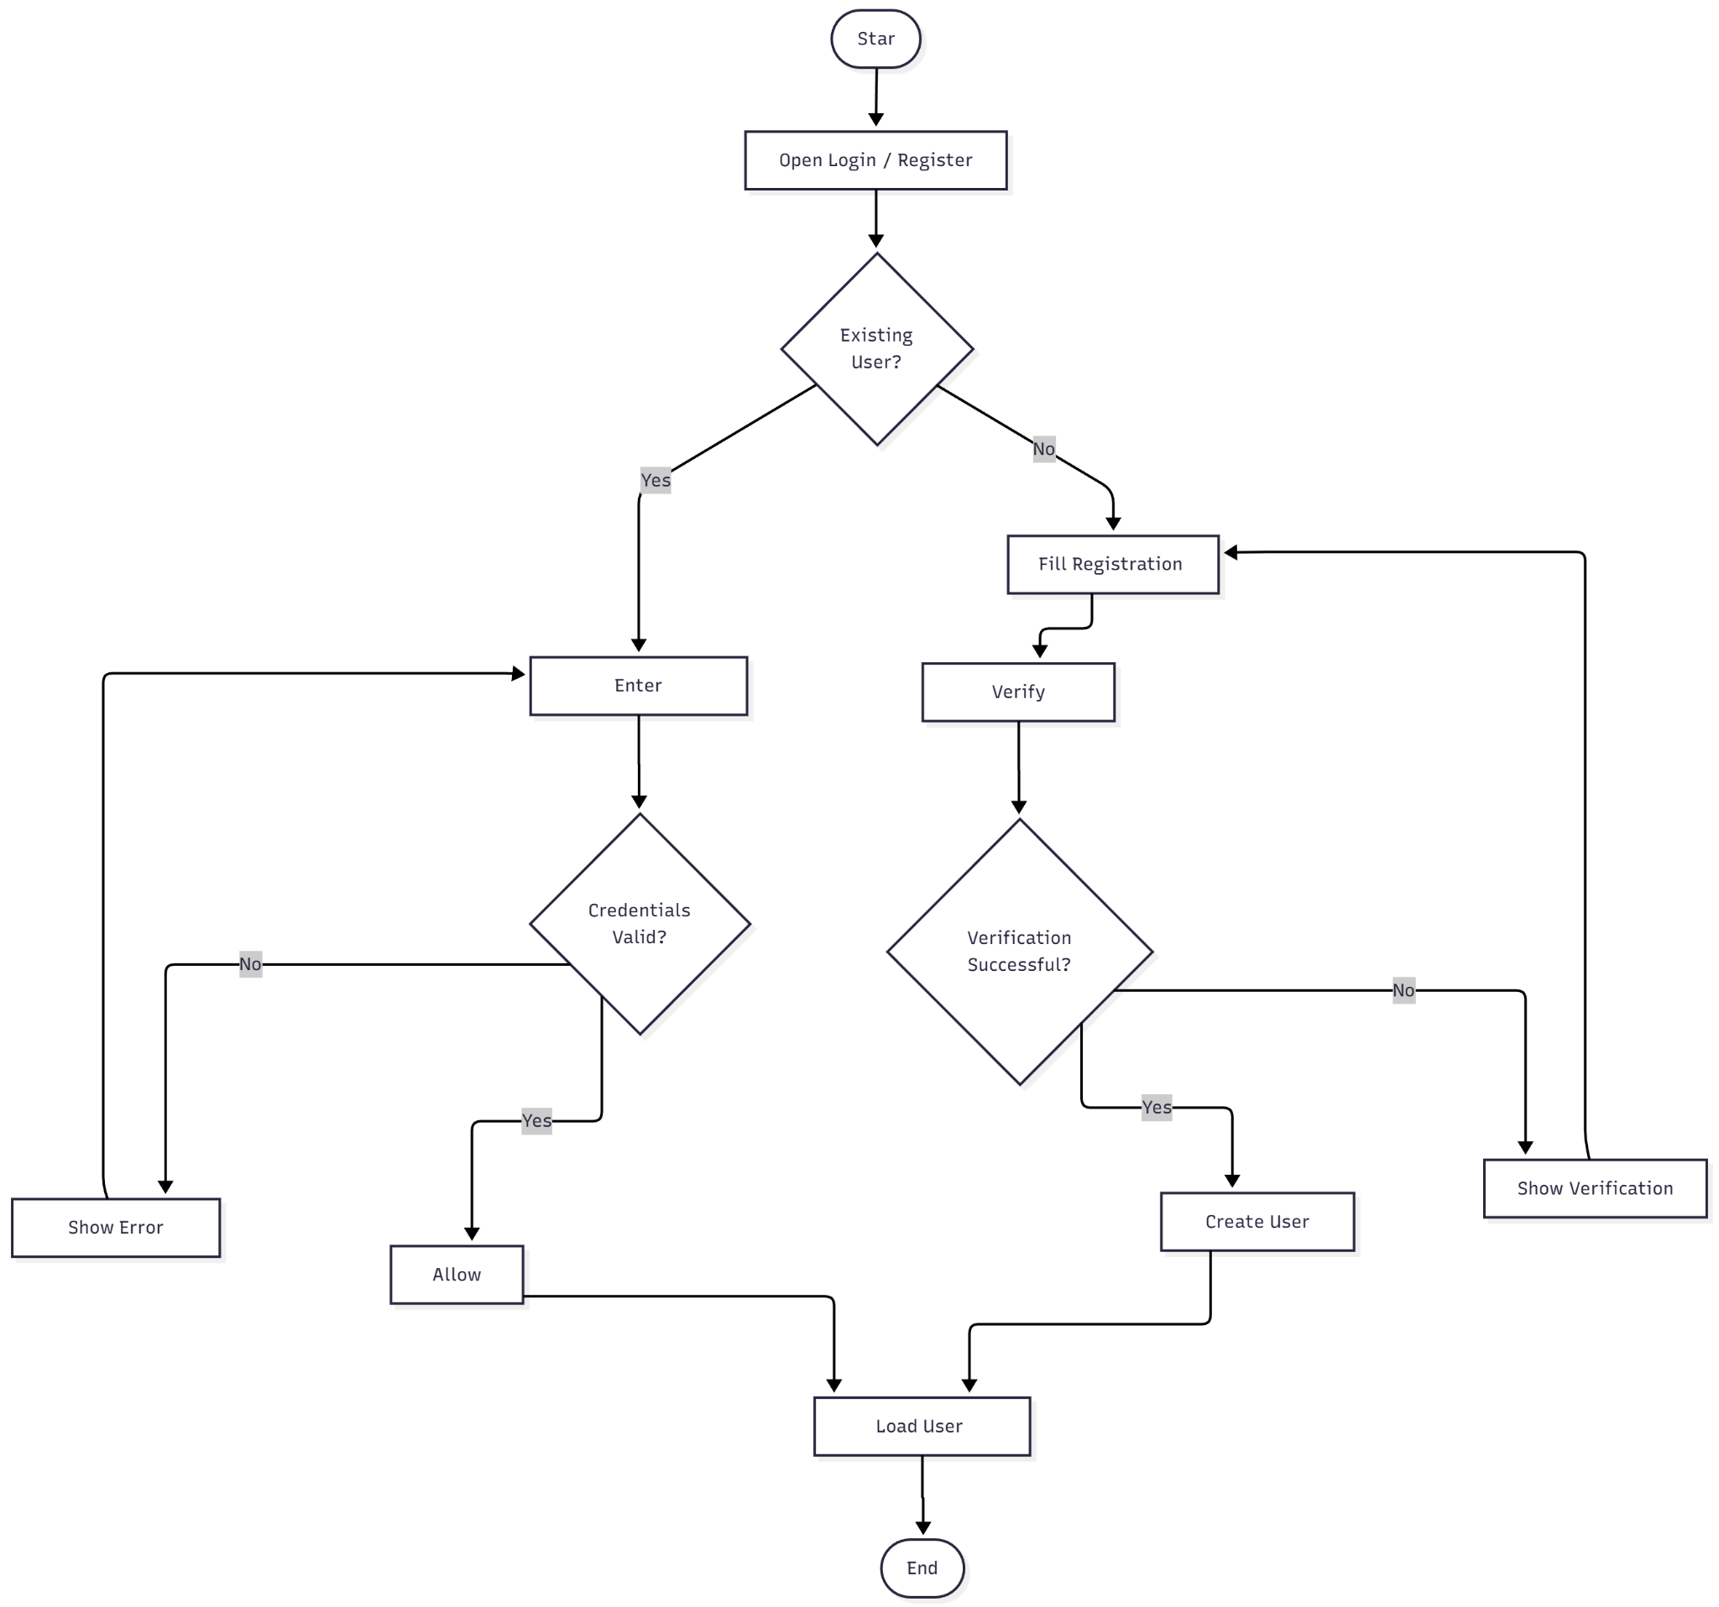

UC-2 Product Listings and Management Module

The seller creates or edits a product listing, the system validates item details, uploads images, applies business rules, and stores the finalized listing in the database.

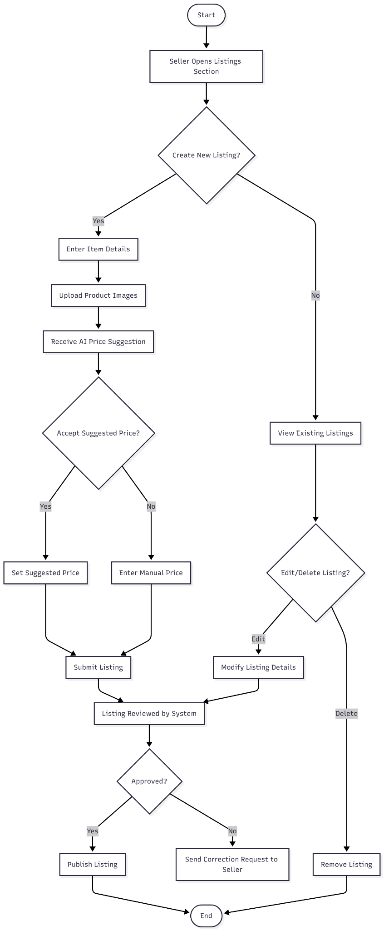

UC-3 Price Prediction Module

The seller enters product specifications, the system processes the attributes, runs the AI pricing model, and returns a fair price suggestion before saving the listing.

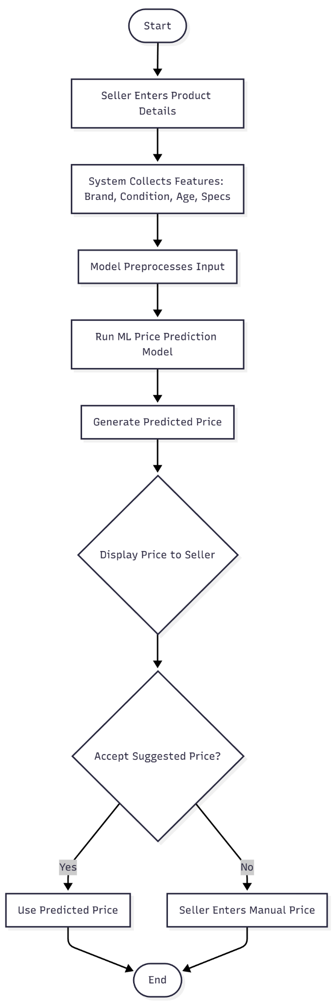

UC-4 Analytical Dashboard

The system collects user activity and listing data, processes trends and metrics, and displays insights such as listing performance and engagement analytics on the dashboard.

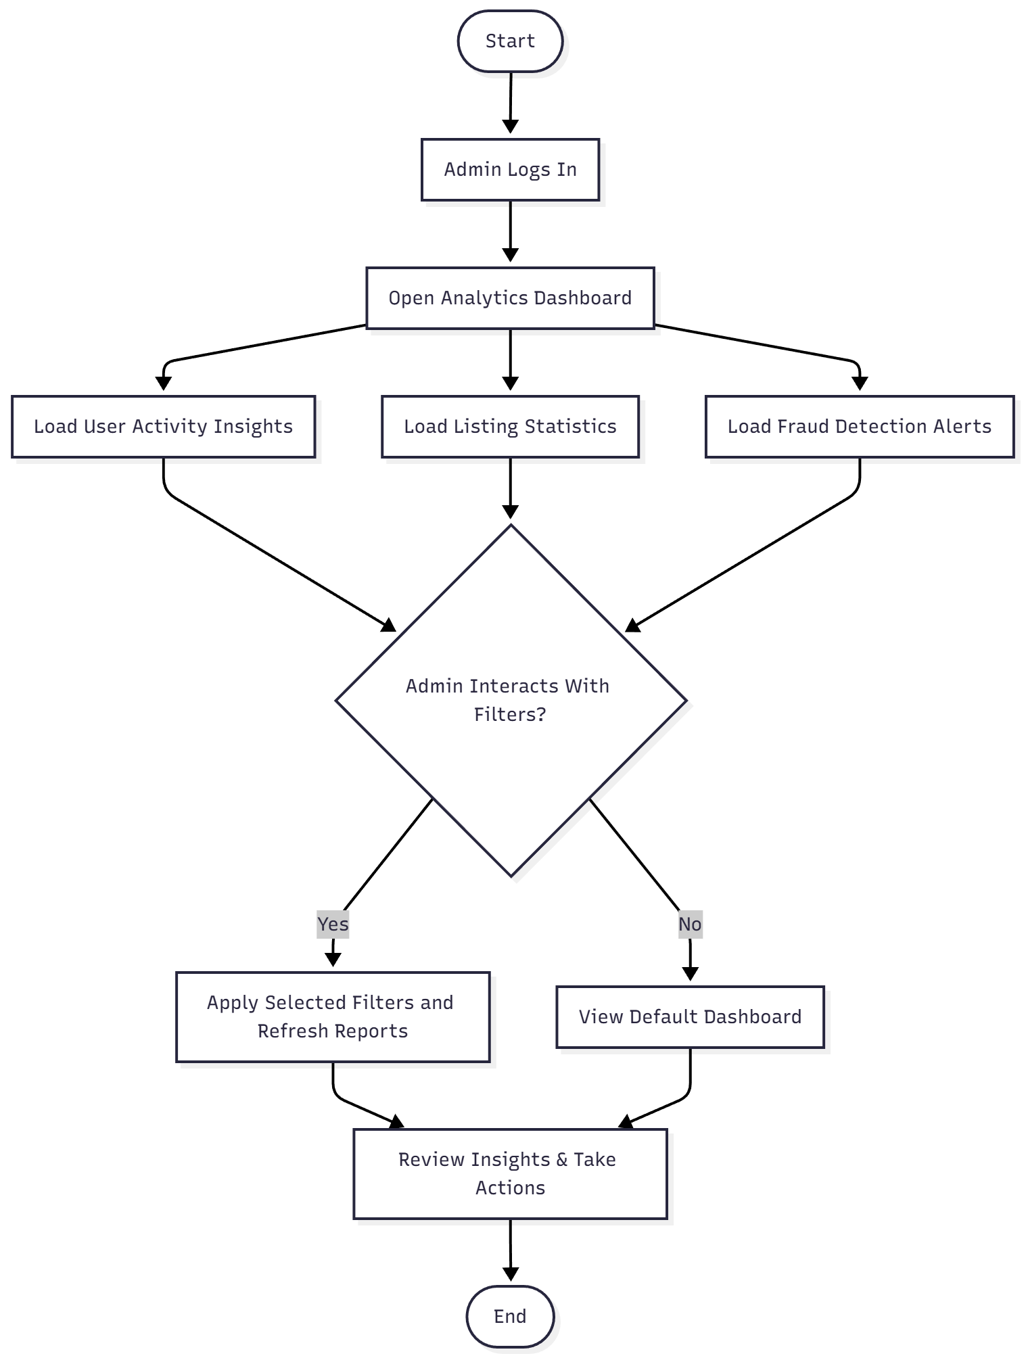

Class Diagram

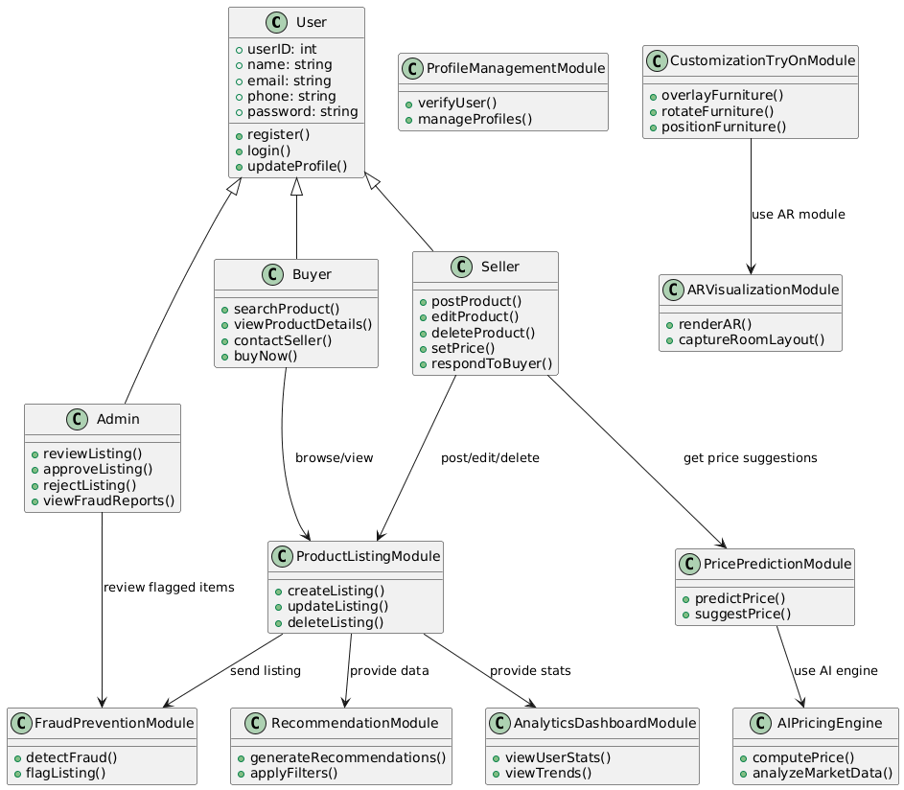

System Sequence Diagram

UC-1 Profile Management
Shows how the user sends registration or login inputs to the system, how the system verifies credentials, and how access is granted along with profile data retrieval.

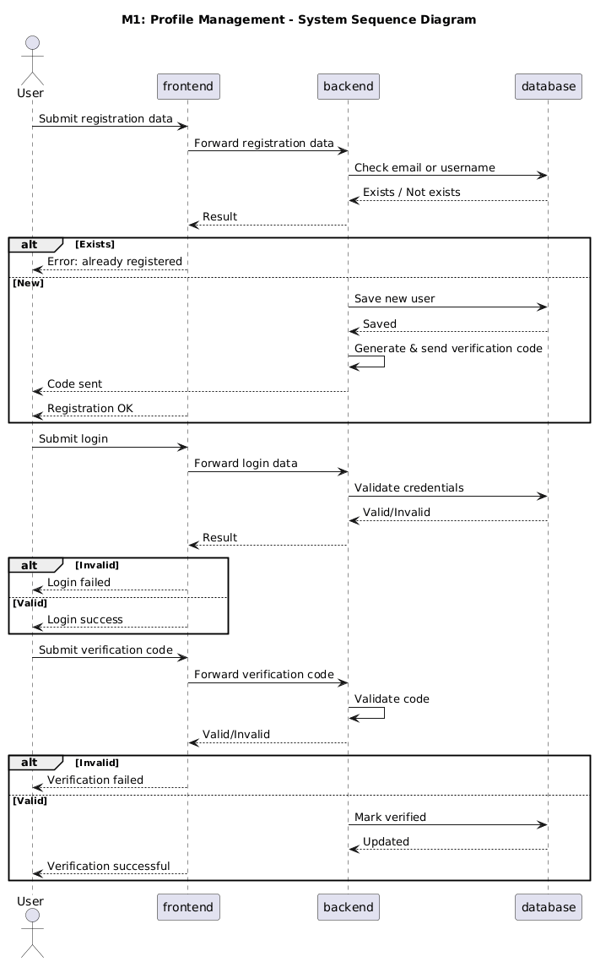

UC-2 Product Listing & Management
Illustrates how the seller submits product details and images, how the system validates inputs, applies business rules, and stores the listing in the database.
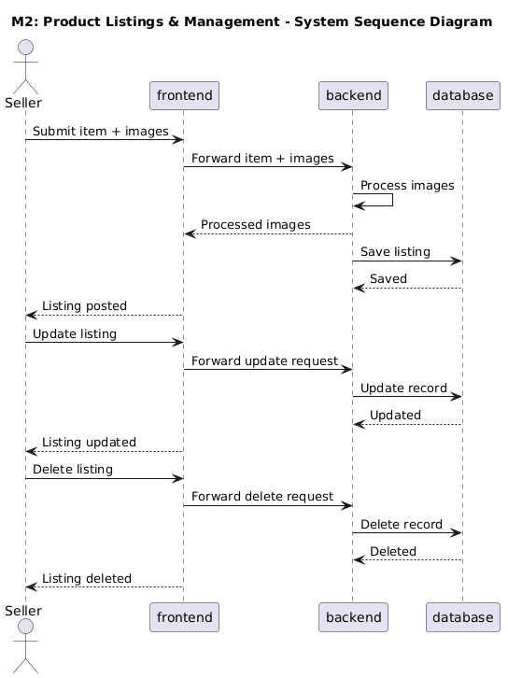

UC -3 Price Prediction
Depicts how the seller provides product specifications, how the system sends the data to the AI pricing engine, receives a suggested price, and updates the listing before publishing.
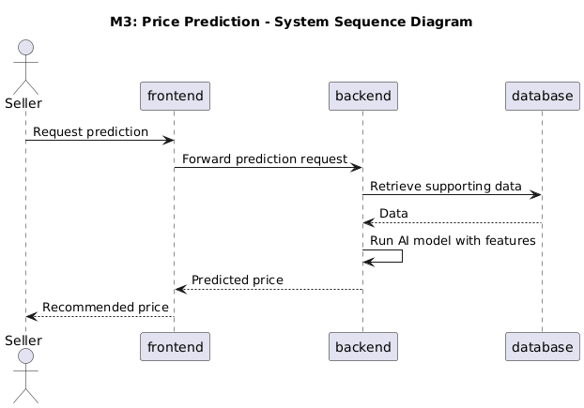

UC-4 Analytical Dashboard
Shows how the system retrieves user and lists data, processes trends and metrics, and displays the insights on the dashboard for buyers, sellers, and admins.

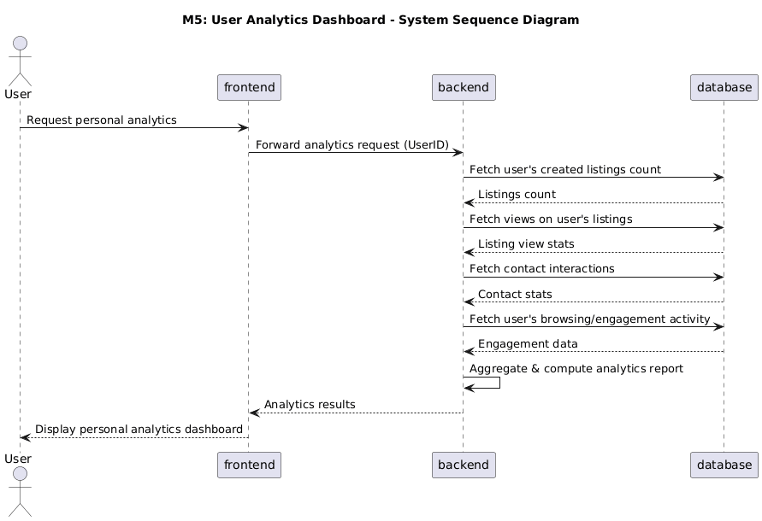

State Transition Diagram

UC-1 Profile Management
Shows how the system moves from “Logged Out” → “Validating Credentials” → “Logged In” if credentials are correct, or “Error” if validation fails.
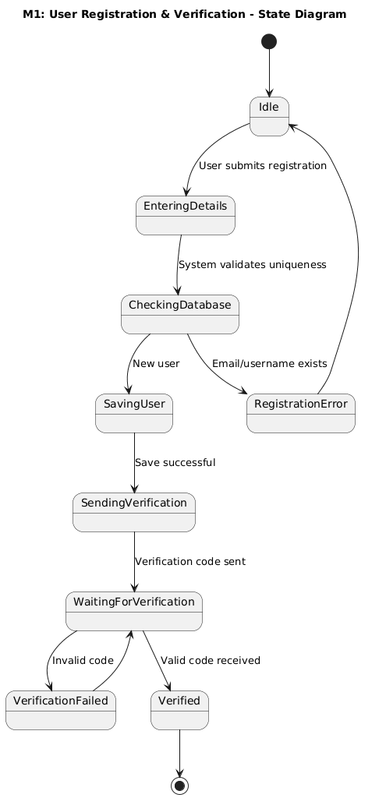

Product Listing & Management
Shows how a listing moves from “Draft” → “Validating Details” → “Published” if all inputs are correct, or “Error/Rejected” if validation fails.

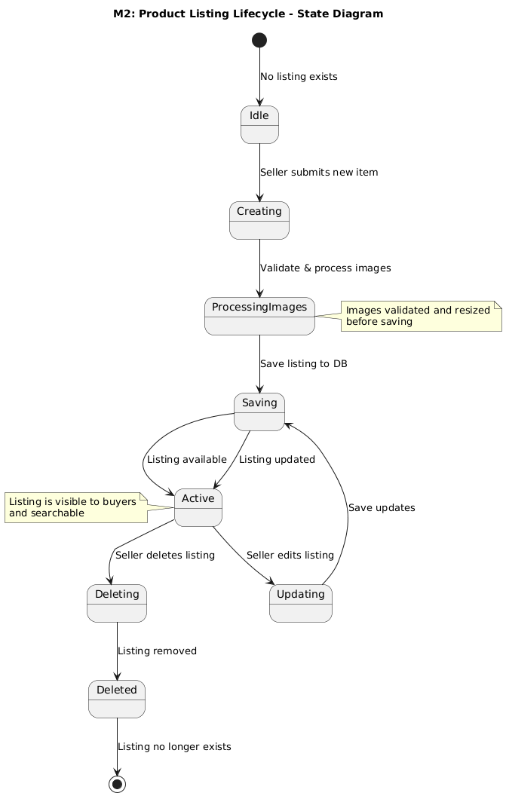

Price Prediction
Shows how a product’s pricing moves from “Awaiting Price” → “Predicting Price” → “Price Suggested”, or “Manual Input Required” if AI cannot generate a valid suggestion.

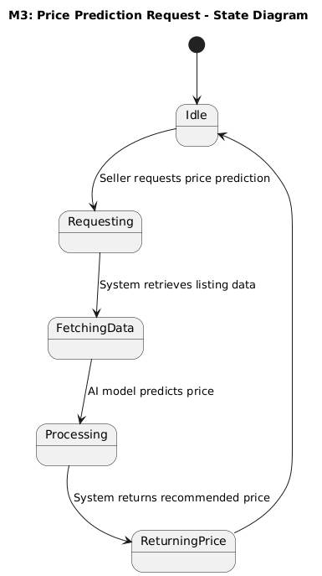

Analytical Dashboard
Shows how dashboard data moves from “Idle” → “Fetching Data” → “Processing Metrics” → “Displaying Insights”.

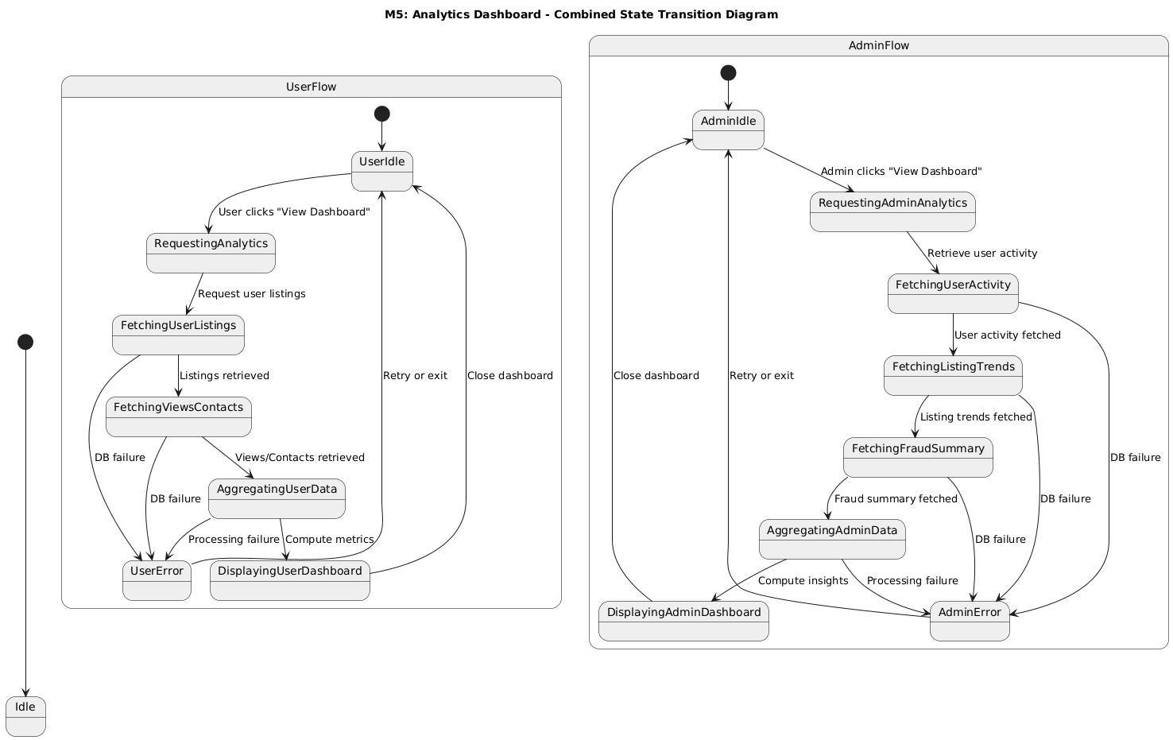

Data Design
The data design explains how EZSell stores and organizes information. The system handles users, product listings, pricing data, AR previews, and analytics, so the goal is to keep everything structured, secure, and easily accessible.

Database Used:
- PostgreSQL (Supabase Instance)
Stores structured data such as user accounts, product listings, AI price suggestions, AR session details, and dashboard analytics. Hosting on Supabase provides managed database services, secure authentication, real-time data syncing, and scalable cloud storage, while maintaining data integrity, relationships between users and listings, and efficient querying for reporting and recommendations.
Data Flow:
- Users register or log in; profile information is verified and stored.
- Sellers create or update product listings, including images and details.
- The Price Prediction module processes listing attributes and stores suggested prices.
- Buyers interact with AR module; session details are saved for analytics.
- Analytics Dashboard reads user activity, listing performance, and AR interactions directly from the database to display insights.
This design ensures efficient data access and keeps all system components synchronized.

Data Dictionary

User
Represents a platform user who can buy or sell items and access dashboard insights.

Attributes:
- id: int → Unique user identifier
- username: str → Login username
- name: str → Full name
- password_hash: str → Hashed password
- role: str → Buyer, Seller, or Admin

Actions:
- Authenticate user
- Retrieve user information

Product Listing
Represents a second-hand product posted by a seller.

Attributes:
- id: int → Unique listing identifier
- title: str → Item name
- description: str → Item details
- category: str → Product category (electronics, furniture, etc.)
- price: float → Seller-entered or AI-suggested price
- images: list[str] → URLs or paths of uploaded images
- seller_id: int → Owner user ID
- status: str → Draft, Published, or Rejected

Actions:
- Create new listing
- Edit or update listing
- Delete listing

Price Prediction
Represents AI-generated pricing suggestions for listings.

Attributes:
- listing_id: int → Associated product listing
- predicted_price: float → Suggested fair price
- confidence_score: float → Model confidence level
- timestamp: datetime → When prediction was generated

Actions:
- Process listing attributes
- Generate price suggestion
- Store predicted price

Analytical Dashboard
Stores processed metrics and trends for display in dashboards.

Attributes:
- user_id: int → Associated user
- listing_views: int → Number of views per listing
- sales_count: int → Completed transactions
- engagement_metrics: dict → Likes, favorites, or interactions
- trend_data: dict → Historical performance of listings and categories

Actions:
- Retrieve analytics data
- Calculate trends and metrics
- Display insights on dashboard

Human Interface Design

Screen Images
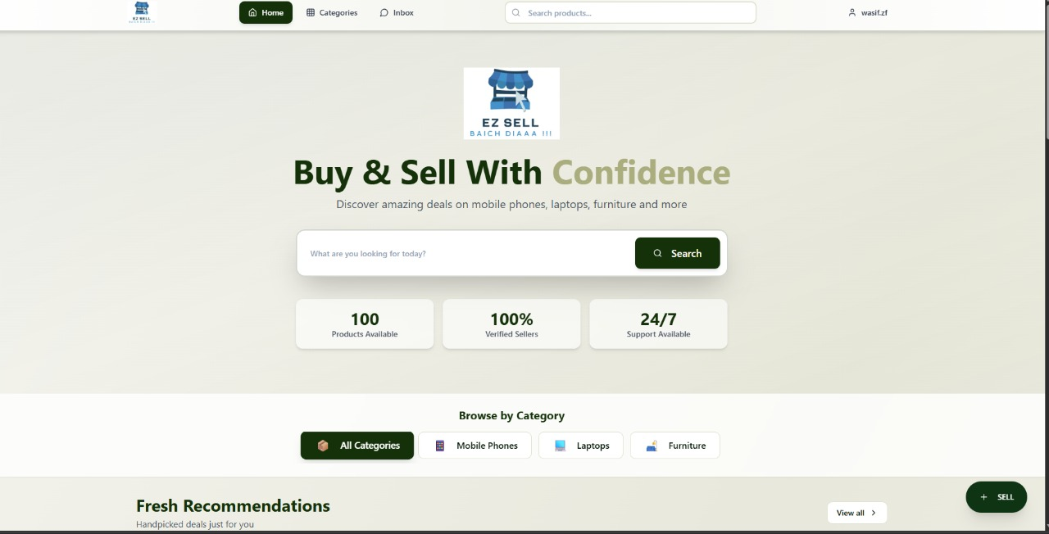

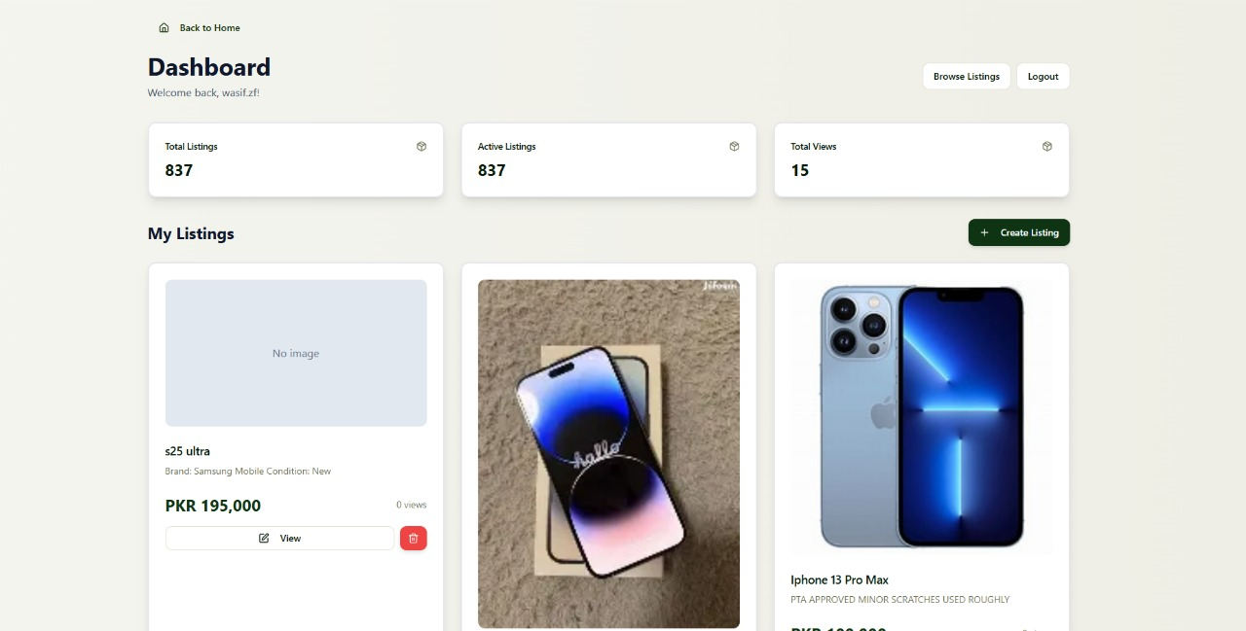

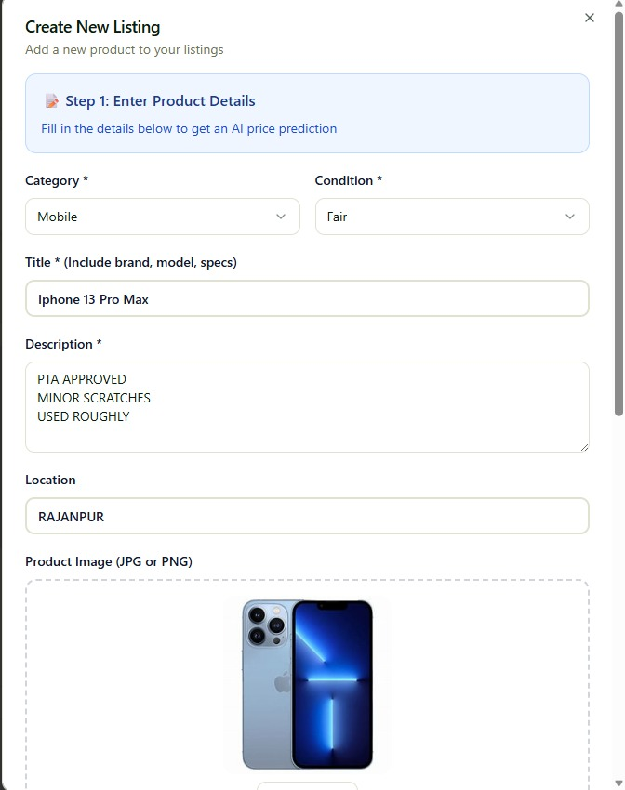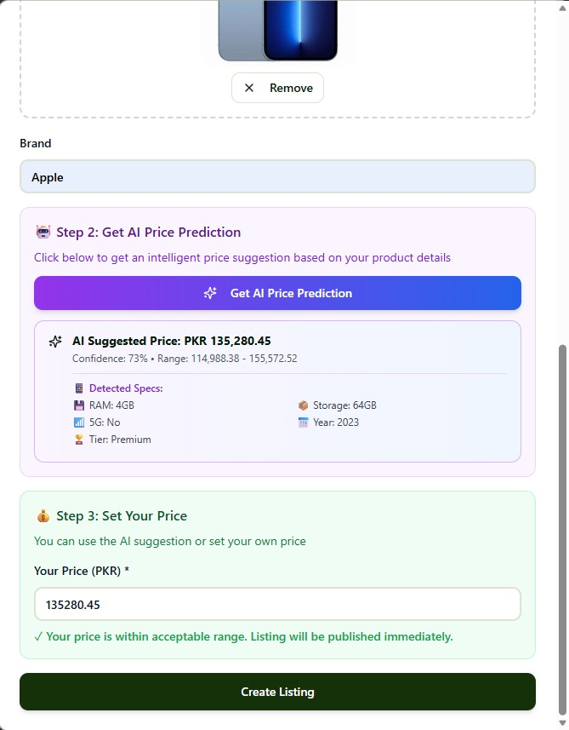

Screen Objects and Actions
1. Logo
- Object Type: Image / Clickable element
- Action: Clicking the EZSell logo returns the user to the homepage from anywhere in the platform.

2. Navigation Bar
- Home Button: Navigates to the homepage.
- Categories Menu: Opens a dropdown displaying product categories (Mobiles, Laptops, Furniture, etc.).
- Inbox Button: Opens the messaging screen for buyer–seller conversations.
- Search Box: Allows users to search for products directly from the top navigation bar.
- User Menu (Top-Right): Opens profile options including My Listings, Account Settings, and Logout.

3. Main Heading + Tagline
- Object: Large text section (e.g., “Buy & Sell With Confidence”)
- Action: No action; provides branding and user guidance.

4. Central Search Box
- Text Field: User enters search queries (e.g., “iPhone 12”).
- Search Button: Executes the search and shows relevant listings.

5. Stats Cards
- Objects Displayed:
  - Total Products Available
  - Verified Sellers
  - 24/7 Support
- Action: Informational only; no clickable actions.

6. Category Filters
- Objects: All Categories, Mobile Phones, Laptops, Furniture
- Action: Clicking filters the product feed based on category.

7. Floating “Sell” Button
- Object Type: Prominent action button (bottom-right corner)
- Action: Opens the Create New Listing screen.

8. Recommendations Section
- Product Cards: Clicking any card opens its detailed product page.
- View All Button: Displays the full list of recommended or trending products.

9. Category Dropdown (Create Listing Screen)
- Object Type: Dropdown menu
- Action: User selects the category for the new listing (e.g., Mobile, Laptop, Furniture).

10. Condition Dropdown
- Object Type: Dropdown
- Action: User selects the product condition (Fair, Good, Excellent).

11. Title Text Field
- Object Type: Text input
- Action: User enters a descriptive product title (e.g., “iPhone 13 Pro Max 256GB PTA Approved”).

12. Description Text Area
- Object Type: Multi-line text box
- Action: User describes item details such as scratches, usage, battery health, etc.

13. Location Text Field
- Object Type: Single-line text box
- Action: User types the physical location of the item (e.g., Lahore, Rajanpur).

14. Product Image Upload Area
- Object Type: Image uploader
- Actions:
  - Upload JPG/PNG product images
  - Remove or replace existing images

15. Brand Field
- Object Type: Read-only field
- Action: Displays detected or selected brand (e.g., Apple, Samsung); no user interaction.

16. “Get AI Price Prediction” Button
- Object Type: Action button
- Action: Triggers the AI model to estimate the product’s price based on provided details.

17. AI Price Prediction Box
- Object Type: Information panel
- Displays:
  - Suggested AI price
  - Confidence percentage
  - Detected specifications (RAM, Storage, Year, 5G status, Tier, etc.)
- Action: User reviews the suggested price.

18. Price Input Field
- Object Type: Numeric text box
- Action: User enters the selling price (either accept AI prediction or set their own).

19. Create Listing Button
- Object Type: Primary action button
- Action: Publishes the product listing after validation of all mandatory fields.

Implementation

7.1 Algorithm
Algorithm 1: User Login
Input: email, password

Output: “Login Successful” OR “Invalid email” OR “Incorrect Password”, session.user_id (if login successful)

1: email_input ← INPUT("Enter Email")
2: password_input ← INPUT("Enter Password")
3:
4: userRecord ← FETCH User WHERE email = email_input
5:
6: if (userRecord = NULL) then
7: DISPLAY "Invalid email"
8: EXIT
9: end if
10:
11: if (HASH(password_input) = userRecord.password_hash) then
12: session.user_id ← userRecord.user_id
13: DISPLAY "Login Successful"
14: else
15: DISPLAY "Incorrect Password"
16: end if
Algorithm 2 — Seller Dashboard
Input: seller choices: “View Listings”, “Add New”, “Edit”, “Delete”
Output: seller dashboard actions (listings shown, edited, deleted, or new ad posted)
1: DISPLAY "Seller Dashboard"
2:
3: CHOICE ← INPUT("Choose: View Listings / Add New / Edit / Delete")
4:
5: if (CHOICE = "View Listings") then
6: SHOW all listings WHERE seller_id = session.user_id
7: end if
8:
9: if (CHOICE = "Add New") then
10: CALL PostAdProcedure()
11: end if
12:
13: if (CHOICE = "Edit") then
14: UPDATE selected listing fields
15: end if
16:
17: if (CHOICE = "Delete") then
18: DELETE selected listing
19: end if
Algorithm 3.1: EZSell detectDuplicateListings | Algorithm 3.2: EZSell detectPriceMismatch
Input: user_id: integer | Input: listing_id: integer, user_price: float
Output: duplicates: Set of flagged duplicate listings | Output: price_flag: Dictionary or NULL
Algorithm 3.1: EZSell detectDuplicateListings  Input: user_id: integer  Output: duplicates: List[Dictionary]  1: duplicates ← []  2: listings ← queryListings(user_id)  3: seen_titles ← {}  4: for each ad in listings do  5: normalized_title ← toLowerCase(trim(ad.title))  6: if normalized_title in seen_titles then  7: duplicates.append({  8: type: "duplicate_title",  9: listing_id: ad.id,  10: duplicate_of: seen_titles[normalized_title]  11: })  12: else  13: seen_titles[normalized_title] ← ad.id  14: end if  15: end for  16: return duplicates | Algorithm 3.2: EZSell detectPriceMismatch  Input: listing_id: integer, user_price: float  Output: price_flag: Dictionary or NULL  1: model ← loadPricePredictionModel()  2: listing_features ← fetchListingFeatures(listing_id)  3: predicted_price ← model.predict(listing_features)  4: lower_bound ← predicted_price * 0.70 // 30% below market  5: upper_bound ← predicted_price * 1.30 // 30% above market  6: if user_price < lower_bound OR user_price > upper_bound then  7: return {  8: type: "price_out_of_range",  9: listing_id: listing_id,  10: predicted_price: predicted_price,  11: user_price: user_price,  12: action: "send_to_admin_review"  13: }  14: end if  15: return NULL

Algorithm 4: Post Ad Procedure (Formatted)
Input: title, description, category, price, images (multiple images)

Output: listing created, listing images saved. confirmation message

1: DISPLAY "Seller Dashboard"
2:
3: CHOICE ← INPUT("Choose: View Listings / Add New / Edit / Delete")
4:
5: if (CHOICE = "View Listings") then
6: SHOW all listings WHERE seller_id = session.user_id
7: end if
8:
9: if (CHOICE = "Add New") then
10: CALL PostAdProcedure()
11: end if
12:
13: if (CHOICE = "Edit") then
14: UPDATE selected listing fields
15: end if
16:
17: if (CHOICE = "Delete") then
18: DELETE selected listing
19: end if
Algorithm 5: Price Prediction Process (Formatted)
Input: listing_features (brand, specs, year, condition, etc.), trained model

Output: predicted_price. confidence score, prediction saved to database

1: listing_features ← INPUT("Enter listing features")
2:
3: model ← LOAD trained_price_prediction_model
4:
5: predicted_price ← model.predict(listing_features)
6:
7: confidence ← model.confidence_score(predicted_price)
8:
9: SAVE prediction(listing_id, predicted_price, confidence)
10:
11: DISPLAY predicted_price, confidence
Algorithm 6: User Dashboard (Formatted)
Input: session.user_id
Output: report: analytics chart (listings count, views, contacts, last active)
1: user_id ← session.user_id
2:
3: total_listings ← COUNT listings WHERE user_id = user_id
4: total_views ← SUM views WHERE user_id = user_id
5: total_contacts ← COUNT messages WHERE seller_id = user_id
6: last_active ← FETCH latest login timestamp
7:
8: DISPLAY analytics_chart(total_listings, total_views, total_contacts, last_active)

Algorithm 7: Admin Dashboard (Formatted)
Input: invoices: none (system retrieves all data)
Output: admin charts (users, listings, fraud, active listings), full summary dashboard
1: total_users ← COUNT all users
2: total_listings ← COUNT all listings
3: active_listings ← COUNT listings WHERE status = "active"
4: fraud_alerts ← COUNT fraud_alerts
5:
6: chart1 ← CREATE user_growth_chart()
7: chart2 ← CREATE listing_trend_chart()
8: chart3 ← CREATE fraud_statistics_chart()
9:
10: DISPLAY dashboard WITH chart1, chart2, chart3, and summary metrics

External APIs/SDKs
No APIs used till now.

User Interface
The user interface is developed using React.js and follows a simple, clean structure. The UI is designed to keep navigation easy and to allow users to move between modules without confusion.
    - Login Screen
A secure page where users enter their email and password to access the EZSell platform.

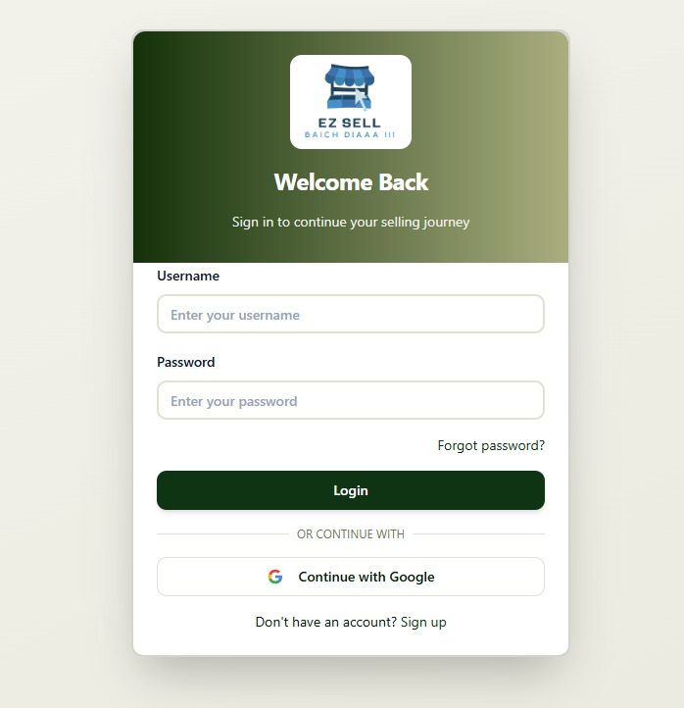
Figure Home Screen

Figure 2 Login Screen

    - Home Screen
Displays all active listings, search options, and navigation shortcuts for users to explore products.



    - Messaging/Communication Screen
Provides a chat interface for buyers and sellers to communicate directly within the platform.

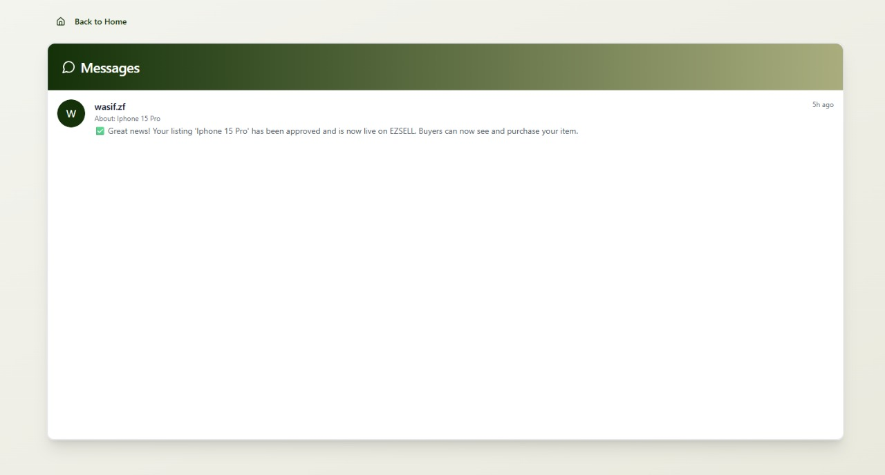
    - Post an AD with AI predictions Screen

Allows users to upload item details and receive an instant AI-generated price estimate before posting the listing.



    - User Analytical Dashboard

Shows personalized insights such as user activity, views on their listings, and performance trends.



    - Admin Analytical Dashboard
Displays system-wide analytics including total users, listings, category trends, and platform performance metrics.

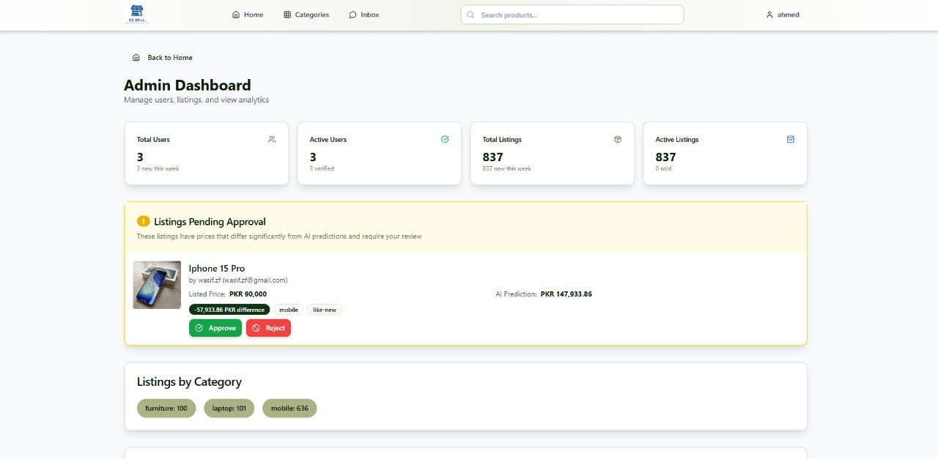

Deployment
- The EZSell platform is deployed on a local host for development and testing.
The backend is built using FastAPI, which handles REST APIs, business logic, authentication, AI price prediction endpoints, and AR processing requests.
- The frontend is developed using React.js and runs on a local Node.js development server, providing a responsive and interactive user interface.
- User data, product listings, AI predictions, AR session data, and analytics metrics are stored in a PostgreSQL database hosted on Supabase. Supabase also manages secure storage for images, listing photos, and AR assets.
- All components communicate over standard HTTP/HTTPS protocols.
This local deployment environment allows developers to test, debug, and refine the application before deploying it to a cloud production server.

Testing and Evaluation

8.1 Deployment Environment (Local Testing Setup)
During development, we ran and tested the whole system on our local machines. The project had two main parts: the backend API and the frontend web application. Both were connected and tested together in a local setup.

8.1.1 Backend Environment

Framework: FastAPI
- Runtime: Python 3.13
- Server Used: Uvicorn (development server)
- Hosting Mode: Localhost (http://127.0.0.1:8000/)
- Main Dependencies:
- fastapi, uvicorn, sqlalchemy, pydantic, httpx, python-jose, passlib[bcrypt], google-genai, python-multipart, python-dotenv, pandas, numpy, matplotlib, prophet, transformers, torch, groq, bcrypt

8.1.2 Frontend Environment (EZSell Project)
- Framework: React.js
- Runtime Environment: Node.js (LTS version)
- Local Hosting URL: http://localhost:8080/
- Package Manager: npm

- Primary Dependencies:
  - React Router (navigation)
  - Axios / Fetch API (backend API integration with FastAPI)
  - State Management (Redux / Context API)
  - UI Libraries (Tailwind CSS / Material UI)
  - Utility Libraries (e.g., date/time formatters, file upload handlers)

8.1.3 Testing Setup (EZSell Project)
- Simultaneous Local Execution:
Both the FastAPI backend and the React.js frontend were run together on the local development system.
- API Communication:
The frontend interacted with the backend using REST API calls over local URLs (e.g., http://localhost:8000/api/...).
- Modules Tested in Local Environment:
All system modules were tested end-to-end, including:
  - User Authentication & Profile Management
  - Product Listings & Media Uploads
  - AI Price Prediction for mobiles, laptops, and furniture
  - User Analytics Dashboard
  - Admin Analytics Dashboard
  - Basic AR Furniture Overlay Module
  - Database CRUD Operations on Supabase (PostgreSQL + Storage)

8.2 Unit Testing
Unit testing checks individual components to ensure each one behaves as expected.

8.2.1 Unit Testing 1: Validate login functionality with correct and incorrect inputs.
Testing Objective: To ensure the login form is working correctly with valid and invalid inputs.

Table 8.2.1: Unit Testing 1 login Functionalities
No. | Test case | Attribute and  value | Expected result | Result
1 | Check valid login | Email:  user@gmail.com Password: ezsell123 | User is logged in and redirected to dashboard. | Pass
2 | Invalid email format | Email: user.gmail.com | Email field shows validation error | Pass
3 | Invalid password | Password: EZsell123 | “Error” message shown | Pass

8.2.2 Unit Testing 2: Listing Image Upload
Testing Objective: Ensure supported file types are accepted and invalid formats are rejected.
Table 8.2.2:
No. | Test Case | Attribute and Value | Expected Result | Result
1 | Upload supported image | image.jpg | File accepted and uploaded to storage | Pass
2 | Upload unsupported format | file.txt | Error | Pass
3 | Upload large file | big_image.webp (5MB) | Error | Pass

8.2.3 Unit Testing 3: Price Prediction
Testing Objective: Ensure that the AI price prediction module correctly processes features and returns a valid predicted price with confidence.
Table 8.2.3
No. | Test Case | Attribute and Value | Expected Result | Result
1 | Predict price for mobile | title=Samsung, condition=used | Return predicted price + confidence | Pass
2 | Predict price for laptop | brand=HP, gen=11th, RAM=8GB | Return predicted price + confidence | Pass
3 | Missing required feature | condition = null | Error | Pass

8.2.4 Unit Testing 4: Listing Creation (Post Ad)

Testing Objective: Ensure that new listings are created successfully with all required fields.

Table 8.2.4
No. | Test Case | Attribute and Value | Expected Result | Result
1 | Valid listing | title, desc, price, category, image provided | Listing saved successfully | Pass
2 | Missing title | title=null | Error | Pass
3 | Price not numeric | price=“ten thousand” | Error | Pass
4 | Image missing | no images uploaded | No image | Pass

8.2.5 Unit Testing 5: Listing Creation (Post Ad)

Testing Objective: Ensure that new listings are created successfully with all required fields.

Table 8.2.5
No. | Test Case | Attribute and Value | Expected Result | Result
1 | Fetch dashboard data | user_id valid | Returns totals (views, listings, contacts) | Pass
2 | No listings | user with 0 listings | Show zero analytics | Pass
3 | Price not numeric | price=“ten thousand” | Error | Pass
4 | Invalid user_id | user_id = null | Error | Pass

8.2.6 Unit Testing 6: Admin Analytics Dashboard

Testing Objective: Verify correct aggregation of platform-wide metrics.

Table 8.2.6
No. | Test Case | Attribute and Value | Expected Result | Result
1 | Fetch system metrics | none | Return totals: users, listings, active listings | Pass
2 | No users available | empty database | Display zero metrics, no errors | Pass

8.3 Functional Testing
The functional testing will take place after the unit testing. In this functional testing, the functionality of each of the module is tested. This is to ensure that the system produced meets the specifications and requirements.

8.3.1 Functional Testing 1:
Testing Objective:
Ensure that uploaded listing images/files are accepted for supported formats and rejected otherwise.

No. | Test case/Test script | Attribute and value | Expected result | Actual result | Result
1. | Upload valid  image | image.jpg | File accepted and  uploaded to storage | Uploaded successfully | Pass
2. | Upload unsupported file type | file.txt | Display error: “Invalid file format” | Error shown | Pass
4  3.  3 | Upload large  file (>5MB) | big_image.webp | Display warning: “File size too large” | Warning shown | Pass

8.3.2 Functional Testing 2: AI Price Prediction
Testing Objective:
Verify that the price prediction engine returns valid prices and confidence for different listings.

No. | Test case/Test script | Attribute and value | Expected result | Actual result | Result
1. | Predict price  for mobile | brand=Samsung, year=2020, RAM=6GB | Predicted price +  confidence score | predicted | Pass
2. | Missing  required feature | year=null | Error:  “Missing features” | Error shown | Pass

8.3.3 Functional Testing 3: User & Admin Dashboard Analytics
Testing Objective:
Ensure that dashboards correctly display metrics for users and admins.

No. | Test case/Test script | Attribute and value | Expected result | Actual result | Result
1. | User  Dashboard  with listings | user_id valid | Display total  listings, views,  contacts | Correctly displayed | Pass
2. | User dashboard  no listings | user with 0 listings | Show “No data  available” | Correctly displayed | Pass
3, | Admin dashboard metrics | all data available | Display total users, listings, active listings | Correctly displayed | Pass
4. | Admin  Dashboard  empty database | no users or listings | Show zero metrics | Correctly displayed | Pass

8.4 Business Rules Testing
Testing Objective:
Verify that business logic rules are correctly applied for listings, price predictions, and anomalies.

- A1: Flag duplicate listing
- A2: Mark unusually high price
- A3: Flag outdated listing
- A4: Flag invalid data entry
- A5: No anomaly

Condition / Rule | R1 | R2 | R3 | R4 | R5
Listing Title Same? | Yes | No | No | No | No
Price unusually high? | Yes | Yes | No | No | No
Very old listing? | No | No | Yes | No | No
Invalid Input / Data Error? | No | No | No | Yes | No
Action | A1 | A2 | A3 | A4 | A5

Integration Testing
Integration testing ensures that different modules work correctly when connected together.

8.5.1 Integration Testing 1: Listing Upload → AI Price Prediction → Dashboard Update

Testing Objective:
Verify the end-to-end flow from uploading a listing to predicting price and updating dashboards.

No. | Test case/Test script | Attribute and value | Expected result | Actual result | Result
1. | Full listing  pipeline | Upload listing | Data saved, price predicted, dashboards updated | Worked end-to-end | Pass

8.5.2 Integration Testing 2: Login → Dashboard → Listings

No. | Test case/Test script | Attribute and value | Expected result | Actual result | Result
1. | User logs in → dashboard loads | Valid credentials | Dashboard loads with: listings feed + “Post Ad” button visible | Works | Pass
2. | User clicks “Post Ad” | Logged-in user | If user chooses, they can create and upload a listing | Works | Pass
3. | User who is only a buyer (behaviourally) ignores “Post Ad” | Buyer-like user | They simply scroll listings, can view but not required to post | Works | Pass
4. | User views listings | Any logged-in user | users can view all listings | Works | Pass

